Title: Pedicled Vascularized Calcaneus Transfer: A Novel Surgical Technique for Tibial Deficiency To Improve Functional Outcome

Authors: William Fang, BS, MS^{1,2}; Evelyn Thomas, DO^{1,2}, Juston Fan, DO^{1,2}; Amber R. Leis, MD^{2,3}; Samuel R. Rosenfeld, MD²
¹Orthopaedic Surgery, Riverside University Health System Medical Center, Moreno Valley, CA
²Orthopedic Surgery, Children’s Hospital of Orange County, Orange, CA
³Plastics Surgery, University of California, Irvine, Orange, CA

Corresponding Author:
Juston Fan, DO
Address: 26520 Cactus Ave, Moreno Valley, CA 92555, USA
Telephone: +1 (505) 259-5822
E-mail: j.fan@ruhealth.org

The authors report no conflicts of interest in relation to this study.
Support: There were no sources of support for this study.

Background: Tibial deficiency (TD), also known as tibial hemimelia, is a congenital lower limb deficiency that involves a spectrum of deformities of the tibia, ranging from a hypoplastic to completely absent tibia.¹⁻³ Due to the rarity of TD and wide spectrum of presentation, there is no standard treatment or reconstructive procedure recommended. In many cases of TD presenting with tibial absence, early ablative procedures or partial amputation are suggested as treatment.^{4.5} Previous reconstruction efforts require prolonged staged surgeries that may take months, which can be detrimental for the patient’s development. To date, there is a lack of reconstructive techniques that prioritize functional outcome and reduced recovery time to promote normal developmental milestone achievement.
Case: A 2-month-old male presented with absent bilateral tibias, with the classification of Paley Type 5c (Figure 1). At 1 year and 24 days, a bilateral fibular resection with pedicled vascularized calcaneus transfer was performed (Figure 2), allowing for transfer of the calcaneus along with the overlying glabrous skin and soft tissues to the end of the femur. The flaps were designed to incorporate residual nerve structures to preserve sensation to the calcaneal skin as well as reduce the risk of neuroma formation. The patient was permitted to bear weight after the four-week post-operative follow-up. After six-month follow-up, the patient was able to pull to stand and walk with assistance without complaints of pain (Figure 3). No complications have been noted up to date at 9-month follow-up.
Discussion: This novel reconstructive technique of bilateral pedicled vascularized calcaneus transfers for bilateral tibial deficiency allowed for the preservation of calcaneal skin, reduced the risk of neuroma formation, and avoided amputation or prolonged staged reconstruction. Due to the nature of a single surgery, non-weightbearing recovery time was decreased, which is crucial for preserving motor and functional developmental milestones.
Images/Tables/Charts:
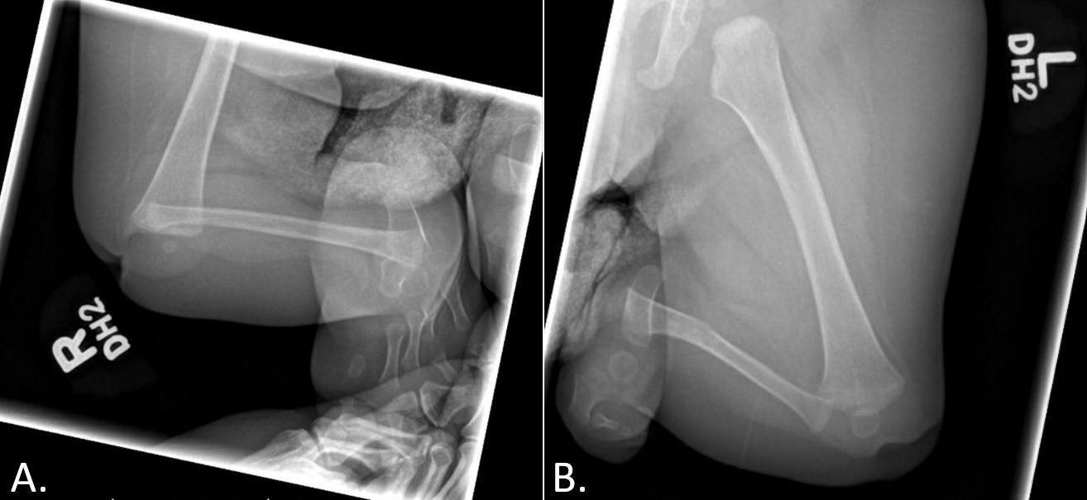
Figure 1: Radiographic when the patient was 8 months old. (A). Anteroposterior view of the right lower extremity Demonstrates absent tibia with dislocation and severe flexion contracture of the knee, and subluxation or dislocation of the ankle; (B). Anteroposterior view of left lower extremity demonstrating absent tibia with dislocation or subluxation of knee and dislocation of ankle.

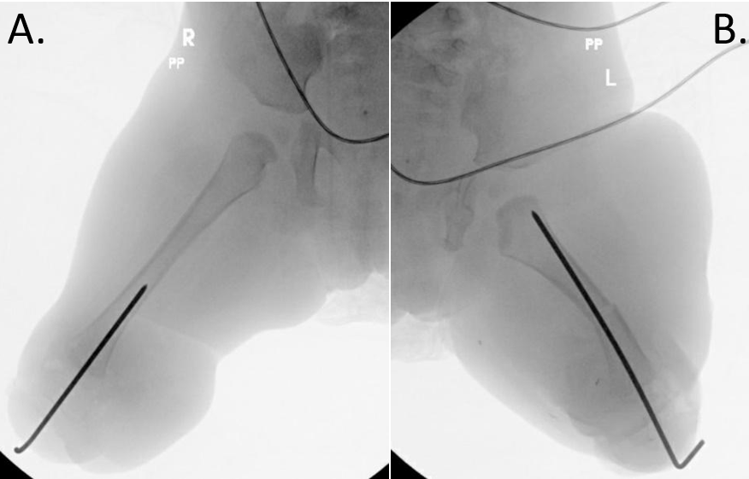
Figure 2: Fluoroscopic anteroposterior image. (A) Right lower extremity demonstrating a smooth pin inserted through the calcaneus into the distal femur; (B) Left lower extremity demonstrating a midshaft femur osteotomy and smooth pin inserted through the calcaneus into the femur.
Figure 3: Patient at 4-week post operative with prescribed Stubbies for weight bearing activities
References:
- Chong DY, Paley D: Deformity Reconstruction Surgery for Tibial Hemimelia. Children 2021;8:461.
- Orimolade E, Ikem I, Oginni L, Odunsi A: Femoral bifurcation with ipsilateral tibia hemimelia: early outcome of ablation and prosthetic fitting. Nigerian journal of clinical practice 2011;14:492-494.
- Sahoo PK, Sahu MM, Das SP: Clinical spectrum of congenital tibial hemimelia in 35 limbs of 24 patients: A single center observational study from India. European journal of medical genetics 2019;62:103666.
- Fernandez-Palazzi F, Bendahan J, Rivas S: Congenital deficiency of the tibia: a report on 22 cases. Journal of pediatric orthopedics Part B 1998;7:298-302.
- Birch JG, Walsh SJ, Small JM, et al.: Syme amputation for the treatment of fibular deficiency. An evaluation of long-term physical and psychological functional status. JBJS 1999;81:1511-1518.

