Abstract Presentation Categories
- Review Article (provide analysis of existing published literature within a specific field)
- Case Report (presents the details of uncommon/unusual patient cases)
- Original Research (presents results obtained by researchers after their creation, design, and implementation of a novel hypothesis)

Abstract Presentation Submission Criteria
- Be sure to select the proper abstract category before submission of your abstract. Selection of an incorrect category will result in the judges receiving the incorrect score sheet causing an inability to accurately score your abstract.
- Information and data submitted in the abstract must be original and all rights owned by the authors at time of submission.
- Only 1 abstract submission is allowed per SAOAO national member.
- Abstracts are not eligible for consideration if the content has been accepted and/or presented at another meeting held in North America prior to the SAOAO conference or a previous SAOAO conference.
- Abstracts are not eligible for consideration if the content has been published as a manuscript in a peer-reviewed journal prior to the SAOAO conference.
- Any abstracts consisting of research carried out on human or animal subjects must obtain Institutional Review Board (IRB) or Animal Care and Use Committee (ACAUC) approval.
- Abstract text is limited to 300 words (this does not include title, subtitles, authors, conflicts of interest declarations, or captions).
- Abstracts must be submitted as a Word document following one of the formats shown below. Submissions not following the format below will not be considered for acceptance.
- Abbreviations and acronyms should only be used after they have been spelled out with their first use in the abstract.
- The primary author of the abstract must be a registered SAOAO national member and currently in good standing at an accredited Osteopathic Medical School.
- Each abstract must include a physician, Ph.D., or research mentor as an author.
- The SAOAO National Executive Board will review all abstract submissions and select a maximum of 10 to be accepted for presentation at the conference.
- The SAOAO National Executive Board will also select a maximum of 5 students who are not able to physically attend the conference as part of an online presentation section to be displayed at the conference.
- Abstracts chosen for presentation will be graded following the “SAOAO Abstract Presentation Grading Rubric” and the top three scoring presentations will be published on the SAOAO website after the conference.
- Abstracts chosen for presentation must be presented by a registered SAOAO national member.
- Abstracts not chosen for presentation may be submitted for presentation at future SAOAO conferences.
- Abstracts not published on the SAOAO website will not be disclosed outside of the SAOAO conference and persons associated with the selection process (e.g., SAOAO National Executive Board members).

- If an emergency arises and the presenter is unable to attend, you must notify the SAOAO at studentaoao@gmail.com immediately so a substitute abstract may be presented.
- Failure to abide by any of the above criteria may result in the abstract not being reviewed or selected by the SAOAO National Executive Board.

Submission guidelines reviewed and updated 1/29/23.

Abstract Presentation Submission Format – Review Article or Original Research
Please submit your abstract following the format presented below.

Title: Brief summary of the abstract convincing the reader the topic is important, relevant, and/or innovative.

Author(s): Names, titles, and affiliations of all contributing persons.

Conflict(s) of Interest: List any situations in which financial or other personal considerations may compromise, or have the appearance of compromising, the researcher’s professional judgment in conducting and reporting the research.

Introduction/Background: Presents the reason the research was conducted, the importance of the research, or the problem the research is attempting to solve. This is also the location of the hypothesis.

Methods: Presents the materials and/or approaches utilized to conduct the research and includes the demographic information of the research participant(s).

Results: Presents the data collected and/or findings observed as a result of conducting the research project.

Discussion: Presents a concise explanation of what can be concluded and the implications of the research. Addresses the generalizability of the results to populations other than that studied.

Images/Tables/Charts: Includes all graphics pertaining to the research. Each graphic should include a title and caption. Be sure to include a legend for the graphic if applicable.

References: Should be structured using National Library of Medicine (NLM) format, as shown below. References should be listed in numerical order as they appear in the body of the abstract.

NLM Reference Format:
List of authors (Last name, First initial, Middle initial). Title of article. Journal name. Date of publication;Volume number(Issue number):Page number(s). Location (URL, PMID, or DOI)

Abstract Presentation Submission Format – Case Report
Please submit your abstract following the format presented below.

Title: Brief summary of the abstract convincing the reader the topic is important, relevant, and/or innovative.

Author(s): Names, titles, and affiliations of all contributing persons.

Conflict(s) of Interest: List any situations in which financial or other personal considerations may compromise, or have the appearance of compromising, the researcher’s professional judgment in conducting and reporting the research.

Background: Presents information relevant to understanding the case (ex: pathophysiology, etiology, clinical features, etc.)

Case: Presents the pertinent history and physical exam findings and lab and diagnostic results of the patient.

Discussion: Presents a concise explanation of why this case is unique to the patient’s condition and how this new information can be generalized to other patients and populations.

Images/Tables/Charts: Includes all graphics pertaining to the case. Each graphic should include a title and caption. Be sure to include a legend for the graphic if applicable.

References: Should be structured using National Library of Medicine (NLM) format, as shown below. References should be listed in numerical order as they appear in the body of the abstract.

NLM Reference Format:
List of authors (Last name, First initial, Middle initial). Title of article. Journal name. Date of publication;Volume number(Issue number):Page number(s). Location (URL, PMID, or DOI)

Sample Abstract Presentation Submission

Title:
Impact of Common Co-Morbidities on Short-Term In-Patient Hospital Outcomes in Total Shoulder Arthroplasty vs Reverse Total Shoulder Arthroplasty

Author(s):
Zakary Rose-Reneau, OMS3, Kansas City University of Medicine and Biosciences Blake Stepanovich, DO, St. Mary’s Hospital Orthopedic Surgery Residency
Elijah Miller, DO, St. Mary’s Hospital Orthopedic Surgery Residency David Dugan, DO, Orthopedics and Sports Medicine Institute

Conflict(s) of Interest:
The authors declare there is no conflict of interest.

Introduction:
Arthroplasty has been used as a treatment option for shoulder disorders for a number of years in the United States. The use of total shoulder arthroplasty (TSA) and reverse total shoulder arthroplasty (RTSA) has increased significantly in recent years^{1,2}. There were over 66,000 shoulder arthroplasty procedures performed in the United States in 2011². Rosas et al showed that reimbursement was significantly impacted by comorbidities in a retrospective study of private payer insurance claims³. Other studies have shown decreased functional outcomes in patients with medical comorbidities⁴. The goal of this study is to show the effect of comorbidities on costs, length of stay (LOS), age at admission, and mortality rate.

Methods:
This retrospective cohort study utilized data from the Nationwide Inpatient Sample (NIS) to identify adult patients (18+) from 2012-2014 who experienced a TSA or RTSA. Of those patients, adult patients were identified using the International Classification of Diseases, 9th edition (ICD-
- codes who were diagnosed with CHF, HTNx HTN, CPD, DM, DMx, COAG, OBESE, anemia, and/or PVD. Patients missing important clinical identifiers (age, gender, death) were excluded. Data analyses assessed hospital LOS, inpatient charges, age at admission, and mortality rate. For LOS, age at admission, and inpatient charges an independent samples t-test was used. For mortality rate, means were compared.

Results:
Of the 38,891 patient sample size, 20,192 patients had undergone a TSA while 18,699 patients had undergone a RTSA. When comparing TSA to RTSA only the presence of CHF affected the percent mortality with p values of 0.024 and 0.014, respectively. For LOS, total charges, and age at admission, 5 (CHF, HTNx, DM, COAG, and anemia) of the 11 comorbidities examined showed statistically significant results in all 3 categories. Total charges showed the greatest differences with COAG (23,797.33), CHF ($18,975.09), and anemia ($15,023.88) patients. LOS showed the

greatest significant differences with HTNx (2.02 days), COAG (1.45 days), and CHF (1.13 days) patients. Age at admission averaged a difference between RTSA and TSA of 4.72 years.

Discussion:
There has been a recent trend towards value-based health care with a focus on outcomes. However, there are baseline differences in patient characteristics that need to be accounted for. This is highlighted by the data retrospectively collected from the NIS database. CHF, HTNx, DM, COAG, and anemia were associated with significant increases in LOS, total charges, and age at admission. The overall mortality rate after TSA and RTSA was also significantly higher in patients with CHF. These factors may need to be considered when evaluating quality-based payment methods.

Images/Tables/Charts:
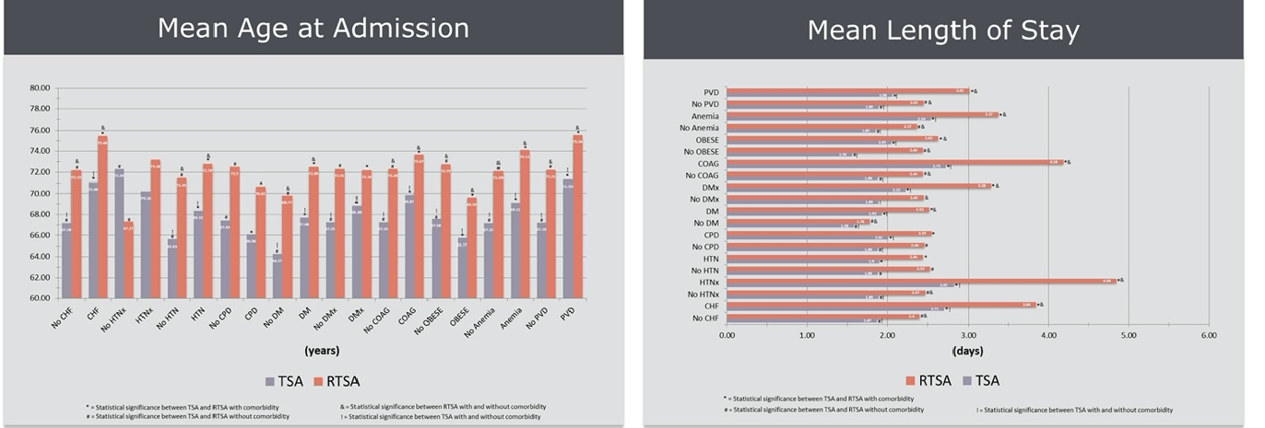
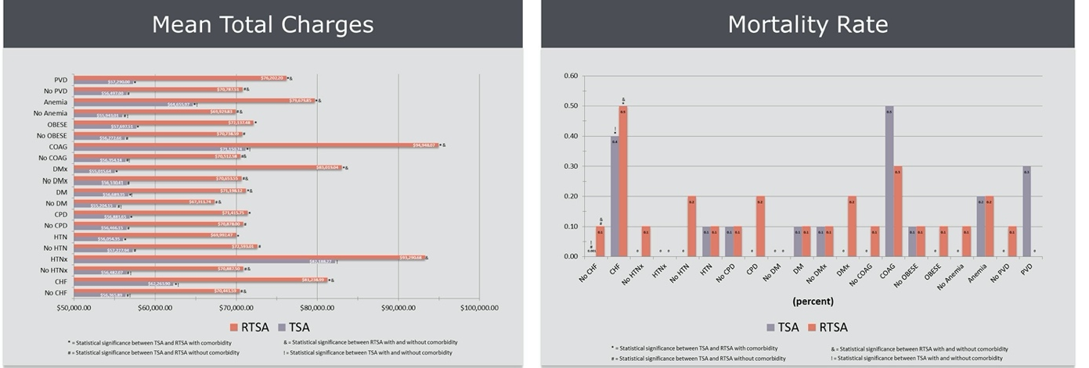

References:
  - Kim S.H., Wise B.L., Zhang Y., Szabo R.M. Increasing incidence of shoulder arthroplasty in the United States. J Bone Joint Surg Am. 2011; 93:2249–2254.

  - Schairer, W. W., Nwachukwu, B. U., Lyman, S., Craig, E. V., & Gulotta, L. V. National utilization of reverse total shoulder arthroplasty in the United States. Journal of Shoulder and Elbow Surgery. 2015; 24(1), 91-97.
  - Rosas, S., Sabeh, K. G., Buller, L. T., Law, T. Y., Kalandiak, S. P., & Levy, J. C. . Comorbidity effects on shoulder arthroplasty costs analysis of a nationwide private payer insurance data set. Journal of Shoulder and Elbow Surgery. 2017; 26(7)
  - Esteras-Serrano, M. J., Ruiz-Hernández, I. M., Gimferrer-Arriaga, J. O., Sánchez-Jimenez, M., Far-Riera, A., & Rapariz, J. Shoulder arthroplasty. Comorbidity as prognostic factor. Journal of Orthopaedics. 2018; 15(3), 889-893.

