Title: An Unusual Case of Cystic Chondroblastoma of the Patella: A Case Report
Introduction:
A chondroblastoma is a rare cartilage-producing benign bone tumor in adolescence and skeletally immature individuals. Typically, Chondroblastomas arise from secondary centers of ossification in the epiphyses of long bones, near growth plates, in the arms at the shoulder, hips, and knees.¹ However, this current case report describes the rare clinical presentation, workup, and treatment of an adolescent patient with chondroblastoma of the patella.
Case Description:
A 14-year-old male presented with left anterior knee pain. He reported the pain was felt inside and underneath the kneecap when running and jumping. Radiographic imaging and magnetic resonance imaging demonstrated a 15x13x9 mm expansile cystic lesion in the patella with a sclerotic border (Figure 1). Image-guided biopsy results indicated a fibro-osseous lesion with sheets of bland mononuclear cells and rare multinucleated osteoclast-type giant cells (Figure 2)
The patient was treated with operative removal of the lesion. Dissection was performed down to the level of the paratenon onto the patella, then a high-speed burr was used to enter the lesion. Bovie electrocautery, high-speed burr, hydrogen peroxide, and normal saline were used in a step-by-step manner to debride any residual lesion. The remaining cavity was filled with a calcium phosphate sulfate solution, and then, a layered closure was performed. After sterile dressings were applied, a cylinder cast in 5° of flexion was applied and allowed to weight bear as tolerated.
Discussion:
Chondroblastomas of the patella are extremely rare as these tumors typically arise in the epiphysis of long bones.² Therefore, the pathology must be distinguished from other bone tumors such as giant cell tumors and clear cell chondrosarcoma based on characteristics and imaging findings.³ The most common treatment for this lesion is curettage with associated bone grafting to maximize functional capabilities. The risk of recurrence of this lesion is high, requiring further clinical and radiological monitoring.
Word Count: 297
Images/Tables/Charts:
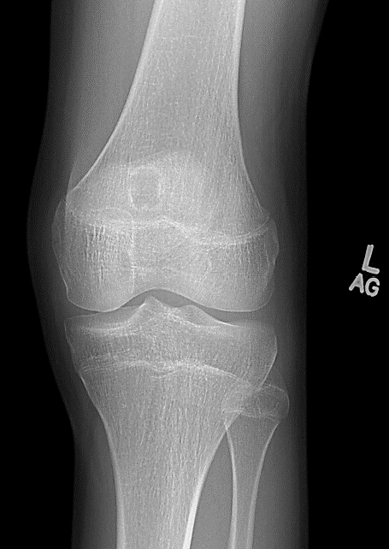
Figure 1. Anteroposterior radiograph of the left knee showing a circumscribed radiolucent lesion with sclerotic margin in the superior middle aspect of the patella.
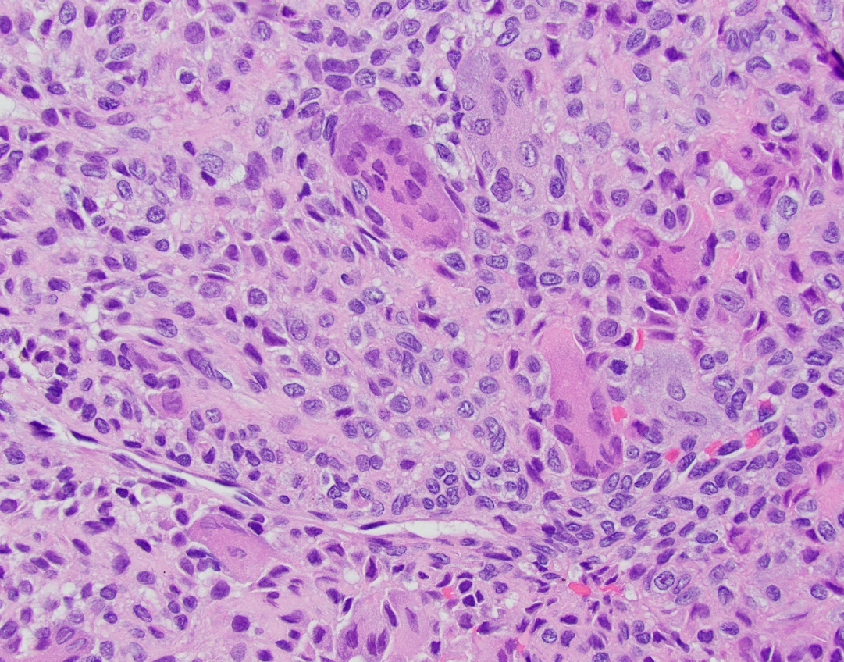
Figure 2: Immunohistological Hematoxylin-Eosin staining: Cystic lesion in the patient’s left knee demonstrating chondroblastoma with proliferating fibroblasts, scattered multinucleated giant cells, and proliferating cartilage tissues.

References:
1. Lin PP, Thenappan A, Deavers MT, et al. Treatment and prognosis of chondroblastoma. Clinical Orthopaedics and Related Research® 2005;438:103-09.
2. Moser RP, Brockmole DM, Vinh TN, et al. Chondroblastoma of the patella. Skeletal radiology 1988;17(6):413-19.
3. Özer D, Arıkan Y, Gür V, et al. Chondroblastoma: An evaluation of the recurrences and functional outcomes following treatment. Acta orthopaedica et traumatologica turcica 2018;52(6):415-18.

