Title: Alterations in Shoulder Tendon Structural Proteins in Atherosclerosis
William H Fang, OM2, M.S.¹, Seerat Sekhon, OMS 2, M.S.¹, Finosh G Thankam, PhD¹, and Devendra K Agrawal, PhD¹.

¹Department of Translational Research, Western University of Health Sciences, Pomona, California 91766, USA

*Corresponding author
Prof. Devendra K. Agrawal, Ph.D. (Biochem), PhD (Med Sci), MBA, MS (ITM), FAAAAI, FAHA, FAPS, FIACS
Senior Vice President for Research & Biotechnology
Professor, Department of Translational Research
Western University of Health Sciences
309 E. Second Street, Pomona, CA 91766, USA
Tel: Off: 909-469-7040; Fax: 909-469-5577
E-mail: DAgrawal@westernu.edu

Conflict(s) of Interest: The authors report no conflicts of interest in relation to this study.
Presentations: None to date

Introduction/Background:
Hyperlipidemia is a hallmark of the atherosclerotic process and can impact every system of the body, including the musculoskeletal system as evident from the increased comorbidity of tendinopathies in atherosclerotic patients.¹ Indeed, lipid deposits within the extracellular matrix (ECM) have been found in tendon tissues with changes in the pathological and biomechanical properties of the tendon.^{2,3} However, there is limited information on the development and progression of tendon pathology in atherosclerotic patients. The purpose of this study was to evaluate the expression status and molecular crosstalk of the ECM proteins in atherosclerosis using a hyperlipidemic microswine model.
Methods:
Shoulder tendons tissue from hyperlipidemic (n=6) and control (n=6) Yucatan microswine were harvested, fixed, embedded in paraffin and thin sections were used for tissue morphology with hematoxylin and eosin (H&E), Masson’s trichrome, and Pentachrome staining. Immunofluorescence staining (IF) was performed for collagen types I, III, IV, V, VI, and XVII, MMP2, and MMP9 following standard protocols. The mean fluorescence intensity (MFI) of each protein was quantified, the variation with respect to control was calculated from the average MFI/nuclei and presented as log₂ fold-change (FC).
Results:
H&E staining showed disorganized ECM in atherosclerotic tissue with greater deposition of adipocytes (Figure 1). Trichrome staining revealed disorganization in collagen fibers with poorly defined vasculature and increased infiltration of adipocytes (Figure 2), and pentachrome staining highlights decreased collagen expression and increased mucin deposition in the atherosclerotic tissues. Also, the atherosclerotic shoulder tendons demonstrated decreased expression of COL III (FC=-0.38±1.49), COL IV (FC= -0.61±1.75), and a pronounced decrease in COL XVII (FC=-1.6±1.85) and COL I (FC=-2.24±0.41). However, there was an increased expression of COL V (FC=1.02±2.13), MMP-9 (FC=0.9±0.60), and a marked increase in MMP-2 (FC=2.05±1.53) in atherosclerotic tissues.
Discussion:
The findings revealed structural alterations in ECM composition and components in hyperlipidemic tendon compared to normal shoulder tendons. There was a decrease in collagen proteins and an upregulation of the MMP class of proteolytic enzymes. The decreased collagen and increased MMP expression are correlated with increased tendon injury and rupture.⁴ Such pathological alterations support the existence of increased co-morbidity of tendinopathies in hyperlipidemic patients.
Word Count: 343
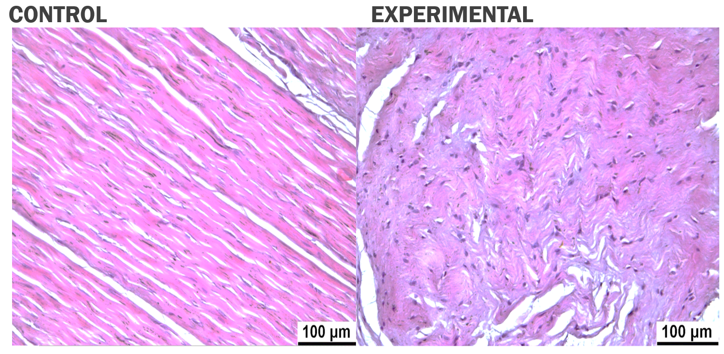
Figure 1: Comparison of Control vs. Atherosclerotic Shoulder Tendon stained with H&E; 20x Magnification
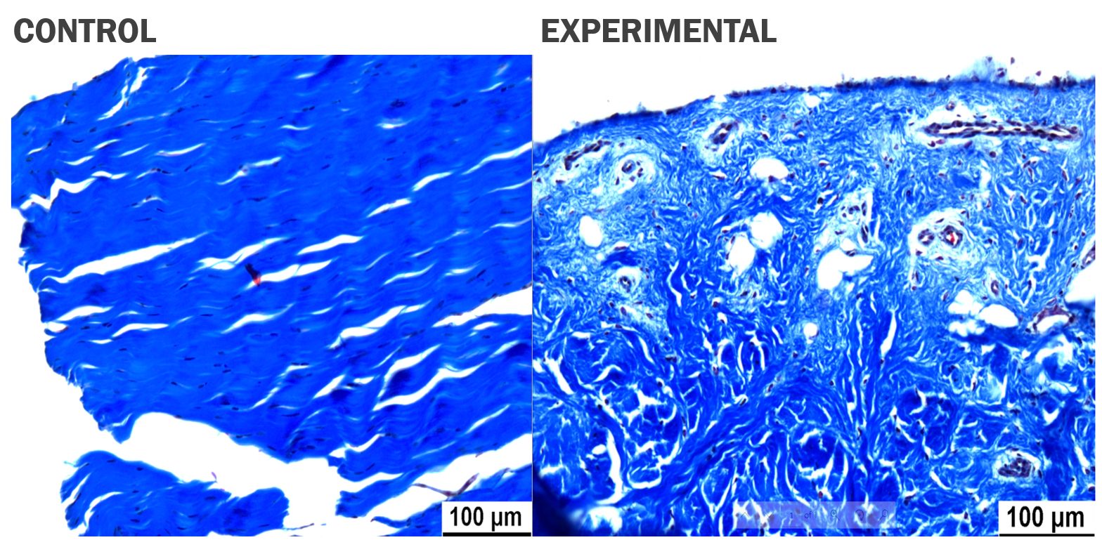
Figure 2: Comparison of Control vs. Atherosclerotic Achilles Tendon stained with Trichrome; 20x Magnification
References:
1. Yang Y, Lu H, Qu J. Tendon pathology in hypercholesterolaemia patients: Epidemiology, pathogenesis and management. Journal of Orthopaedic Translation. 2019;16:14-22.
2. Beason DP, Abboud JA, Kuntz AF, Bassora R, Soslowsky LJ. Cumulative effects of hypercholesterolemia on tendon biomechanics in a mouse model. Journal of Orthopaedic Research. 2010;29(3):380-383.
3. Beason DP, Tucker JJ, Lee CS, Edelstein L, Abboud JA, Soslowsky LJ. Rat rotator cuff tendon-to-bone healing properties are adversely affected by hypercholesterolemia. Journal of Shoulder and Elbow Surgery. 2014;23(6):867-872.
4. Ma J, Piuzzi NS, Muschler GF, Iannotti JP, Ricchetti ET, Derwin KA. Biomarkers of rotator cuff disease severity and repair healing. JBJS reviews. 2018;6(9):e9.

